Common Infections -what can I do and when should I see a doctor?
Please read this and think carefully about whether you still need a GP appointment. If you are still worried then please get in touch with the surgery.

Most colds, coughs, ear infections, sore throats, tonsillitis, sinusitis, bronchitis (chesty cough), and diarrhoea & vomiting do not get any better any quicker with antibiotics. Antibiotics can cause side effects like tummy upset, rash and thrush.

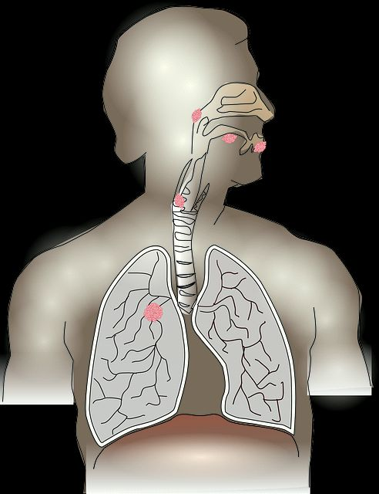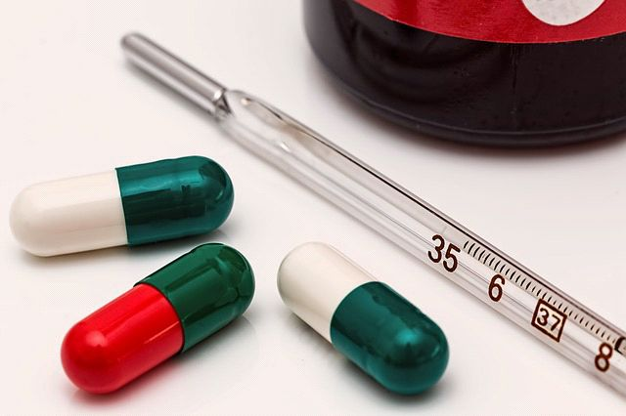

What's the problem with taking antibiotics? Is there any harm?
1. Side effects including upset stomach, diarrhoea, rash, & thrush.
2. Antibiotic resistance meaning the next time you have the antibiotic it doesn't work for you.
3. The local community can develop antibiotic resistance so others living in this area also find the antibiotic doesn't work when they need it.
4. Antibiotics are very expensive leaving less NHS money to treat sick patients.

How long can I expect this illness to last?
The graph below shows how long most of these illnesses normally last.
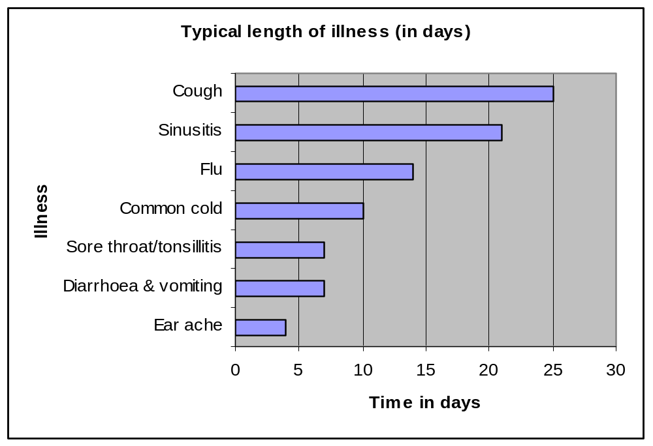
Sometimes infections can last even longer. This is normally nothing to worry about and antibiotics won't change this.



When should I seek advice from a doctor?

In the rare case that you or someone you know develops any of the symptoms below then you should contact your GP or NHS 24 (tel 111) as these might suggest a serious illness.
- a) a) Severe headache and vomiting, especially with a fever.

b) Severe pain and/or swelling at the front of the head or around the eye or swelling of the face, or bloodstained discharge coming from the nose.

- c) Cold or clammy with an unusual rash that does not go white with a glass over it.

d) Confusion or slurred speech or are very drowsy

e) Drooling or severe difficulty swallowing

f) Difficulty breathing. Signs that suggest breathing problems can include:
- breathing quickly
- skin between or above the ribs getting sucked or pulled in with every breath

g) Coughing up blood

h) Chest pain that you don't think is because of your coughing

i) Severe abdominal pain

j) If children are drinking and passing urine a lot less than normal (< 50%), especially if under 1 year and vomiting.
(Most children can go a few days without eating much).

k) A baby less than 3 months with a temperature above 38ºC, or a baby less than 6 months with a temperature over 39ºC.


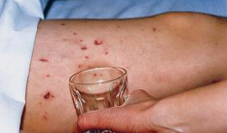
Image from Meningitis Trust


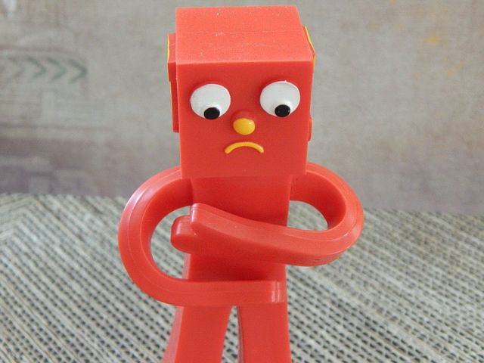
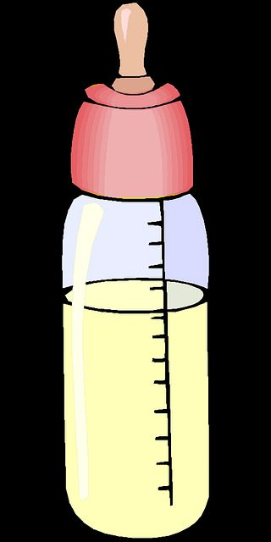
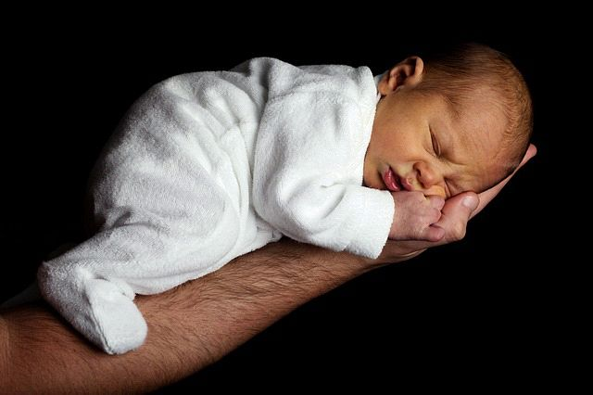
* Consider getting in touch sooner if you are over 80 and have diabetes, heart failure, have been admitted to hospital in the last year, are taking steroids, or are on lots of medications. *

What can I do when I have an infection?
1.Drink plenty of fluids to avoid dehydration (little and often if you or your
child struggle to drink a lot in one go).
Avoid fruit juice and fizzy drinks in children as this can make any diarrhoea worse.
If you are showing signs of dehydration such as a dry mouth and dark urine then you can get rehydration drinks from the pharmacy.
If your child is drinking less than half the amount they normally would, and they are passing urine a lot less than normal, or having lots of dry nappies, then speak to a doctor.



2. If in pain then you can try paracetamol and/or ibuprofen. It is OK to alternate them or take them both together, just make sure that you don’t take more than the recommended dose of each.
Pain relief is often more effective if you take it regularly (3 or 4 times a day) rather than just as a one off.
Don't use ibuprofen if there are concerns about dehydration because this can affect the kidneys.

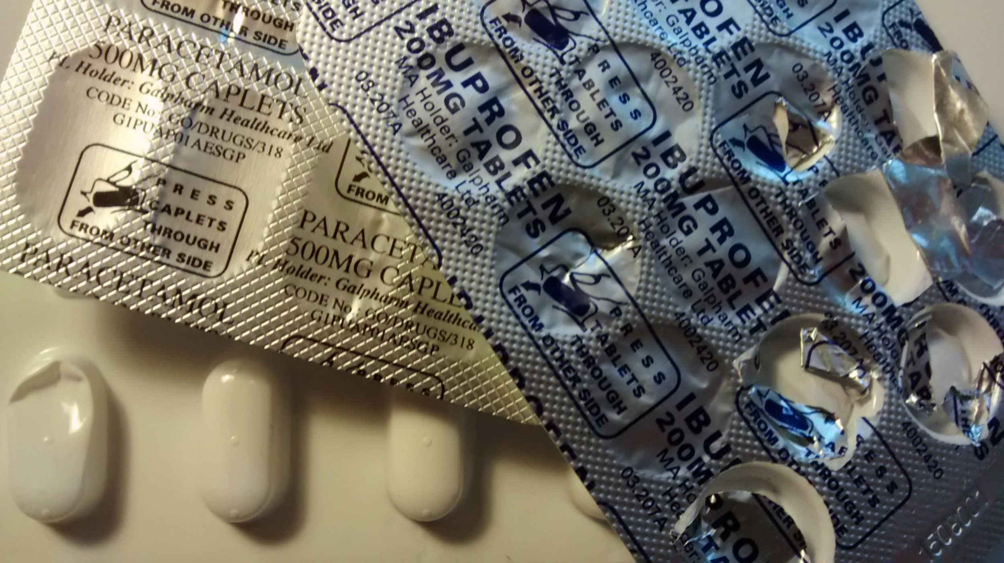

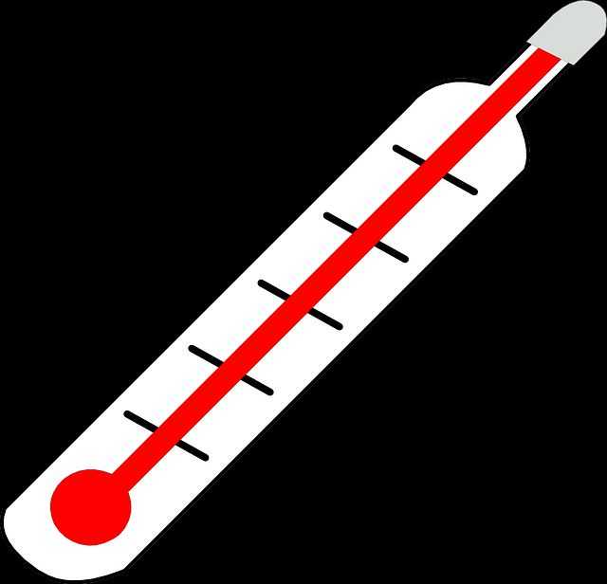
3. Fever is a normal response that may even help to fight infections and doesn't harm you or your child. Take off outer clothing but don't use tepid sponging as this can actually increase body temperature. If in distress as a result of a high temperature then you can use paracetamol (or ibuprofen).

Babies are different. If your baby is under 3 months and has a temperature of 38ºC+, or under 6 months and has a temperature of 39ºC+ then we recommend that you speak to a doctor.

4. Wait for your symptoms to gradually improve, unfortunately this can sometimes take a lot longer than we would like or expect (possibly weeks). This is normally nothing to worry about.



5. Visit your pharmacy, some people find over the counter remedies help.

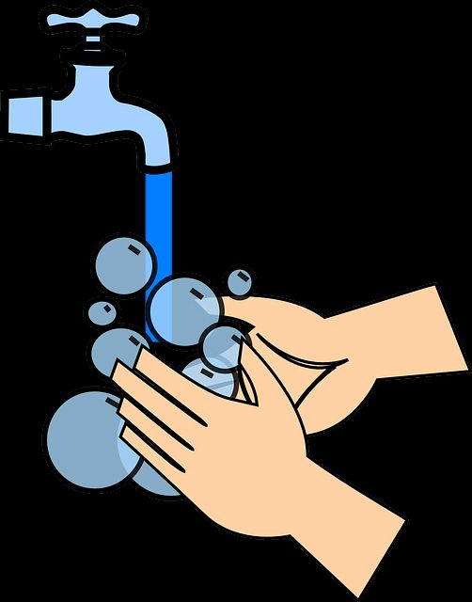
6. Wash your hands regularly and use a tissue to help prevent spread of infection to others and reduce the risk of future infections.
Other information
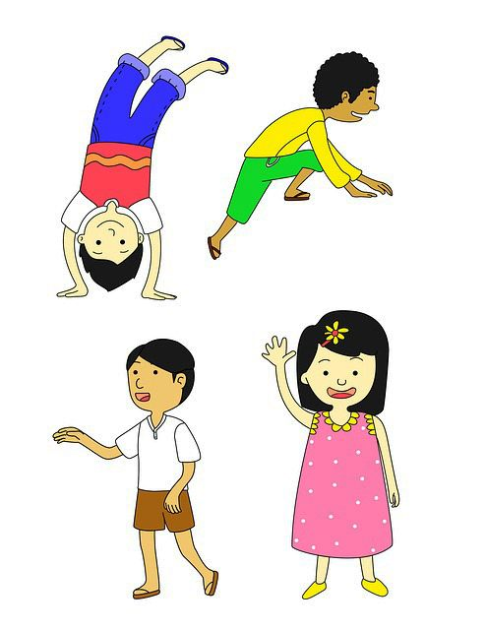
Normal healthy children can sometimes have 8 or more colds in a year! Most children with a cold, cough, sore throat or earache, who see their GP, will still be ill 4 days later. This doesn't mean they need treatment or need to be seen again.

♫♪ Young children often get noisy chests when they catch a cold. This is because they have smaller airways and thinner rib cages than adults but it doesn't mean they have a serious chest infection (which would normally make them very unwell). ♫♪
Ear infections can last 7 days but 60% of children are better in 24 hrs.
If your child is under 2, has a temperature (>38ºC) and has ear infections both sides then antibiotics may be of some benefit.

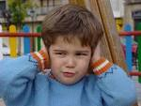
Green phlegm - This can happen during infection, but does not mean you need antibiotics or to see a doctor unless you are feeling very unwell.
Rashes occur during infections and these often settle down on their own.
If someone is severely unwell and/or has an unusual rash that doesn't turn white when you put a glass over it, then seek advice urgently.
Image from the Meningitis Trust, www.meningitisnow.org

Smoking can increase your risk of infection and make your immune system less effective at fighting infection, and it can have this affect on others around you too. (Speak to your pharmacy for support or contact South Edinburgh stopping smoking line: 0131 537 7154).
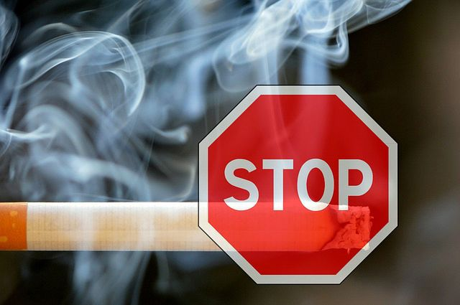
The Minor Ailment Service (MAS) allows eligible patients to register and use the community pharmacy as the first place to go to for treatment of common illnesses on the NHS. This includes people under 16 and over 60 as well as people on income support and others.
(For more details please see http://www.communitypharmacy.scot.nhs.uk/).

A fitnote (sickline) is only required if you take more than 1 working week off work because of ill health. You can self certify for the first 7 days.
Avoid work/school/childcare until 48 hours after diarrhoea or vomiting to reduce the spread of infection.



Firrhill Medical Centre, references: RCGP Target antibiotic toolkit, GP Update Handbook, Global Respiratory Infection Partnership
Images copyright free and mostly taken from www.pixabay.com.

